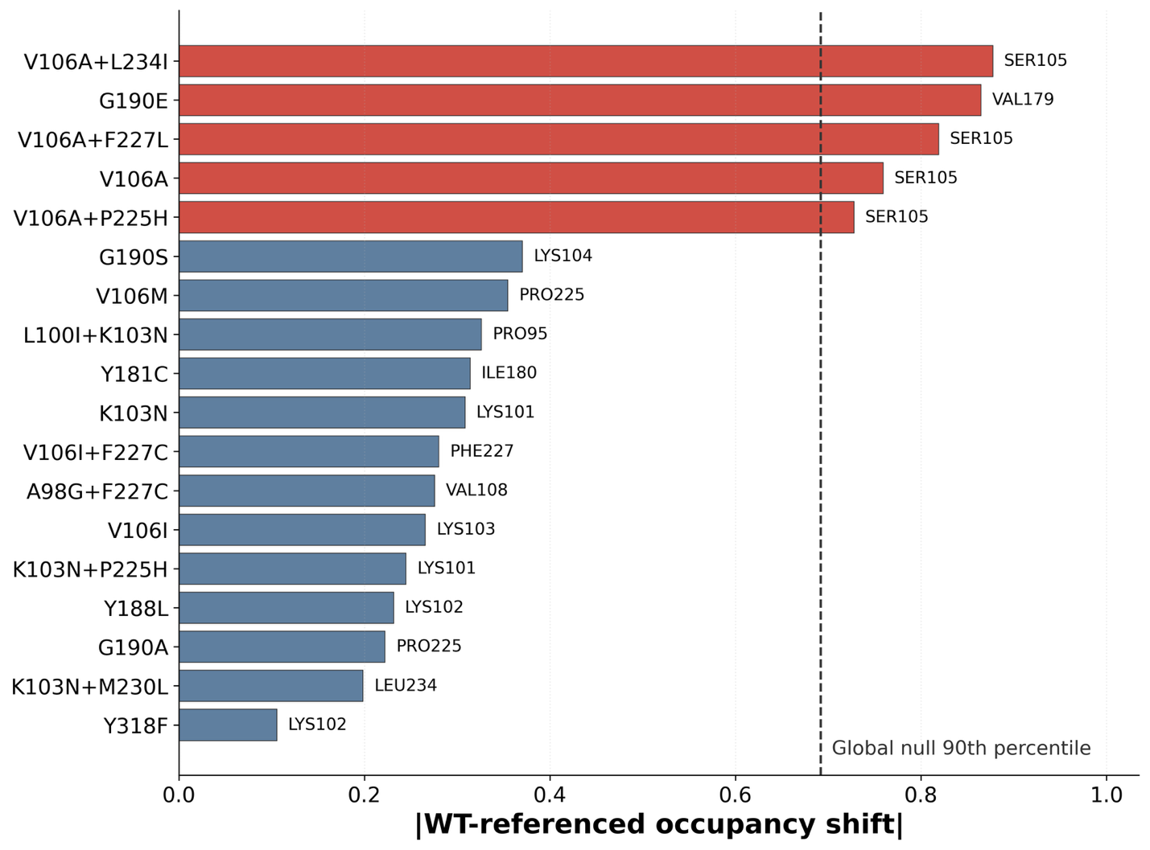
Supplementary Figure 1. Trajectory-level permutation analysis identifies mutation-specific DOR contact-occupancy shifts exceeding a global empirical null.
For each mutant RT-DOR system, the strongest WT-referenced DOR contact-occupancy shift was identified across the 27 WT-contacted NNRTI-binding pocket residues used in the contact-occupancy heatmap (Figure 5 in the main text). Bars show the maximum absolute occupancy shift for each genotype, and the residue label at the end of each bar indicates the residue responsible for that maximum shift. Occupancy shifts were calculated relative to WT after pooling replicate trajectories for each genotype. To estimate the magnitude of shifts expected from trajectory-to-trajectory variability alone, mutation labels were permuted across the 57 replicate trajectories while preserving the original number of trajectories per genotype. For each of 10,000 permutations, pooled WT-referenced occupancies were recomputed and the largest absolute shift observed across all mutant-residue comparisons was recorded, generating a multiple-comparison-aware global null distribution. The dashed vertical line marks the 90th percentile of this global null distribution, corresponding to an absolute occupancy shift of 0.692. Red bars indicate genotype-residue shifts exceeding this global threshold, whereas blue bars indicate shifts that do not exceed the threshold. Five genotype-residue coordinates exceeded the global 90% null threshold: V106A+L234I-Ser105, G190E-Val179, V106A+F227L-Ser105, V106A-Ser105, and V106A+P225H-Ser105. These results support the selection of Ser105 and Val179 as reporter coordinates whose observed shifts are larger than expected from replicate-level sampling variability when screening the same set of pocket residues across the genotype panel.

